Two mathematical procedures machine learning use:
1. Statistics and probability:
It means that everything we are doing is based in simple mathematics.
They are trying to reduce the amount of loss.

Computers can only do 4 things, add, minus, multiply and divides.
When dealing with words it cant do maths on it, so what we do is encode the text.
We represent the words as numbers, that’s what encoding is.

As we deal with data techniques we need to continually check it back, every data set is different and must be considered a brand new page.

Label/ordinal encoding – represent the value with a number. Coke =1, coffee = 0.
The issue is that there is some machine learning algorithms which think these numbers have a Mathematical relationship. Typical in the sklearn libraries, need to check the documentation.

Need to break any unintended mathematical, 1 hot encoding or dummy encoding.
Basically ask if its true or false, 1 = True, 0 = false

For each one of our categories we create a new feature/column
DrinkCoffee , DrinkCoke.
In this row do I have the term coffee, I do so = True

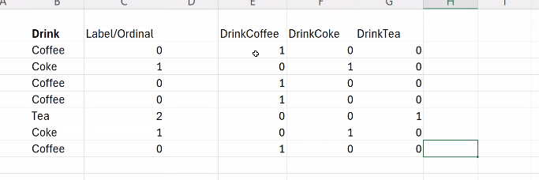

If we have 30 categories it will return 30 columns, the curse of dimensionality, the more columns we have the harder it will be for the machine learning algorithm to find patterns on the data.
Lots of 0s too means the data becomes sparse, negative on the ML.

